CSD-4464 Programming Java EE

WEEK 8

Assignment 4

Date: 18th March 2022

Output

Group E Members:

Anirudh Vallampatla C0796429

Meghana Kondaveeti C0784302

Srikanth Ajith Kumar Yarram C0793406

Vishal Kumar C0793379

Yamini Rathod C0796390

Folder Structure

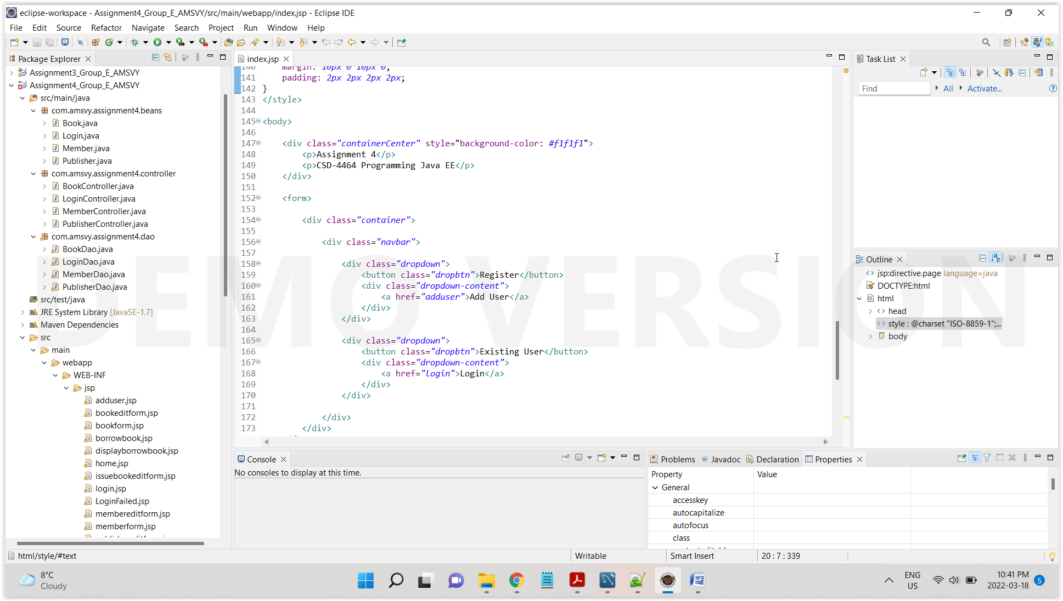

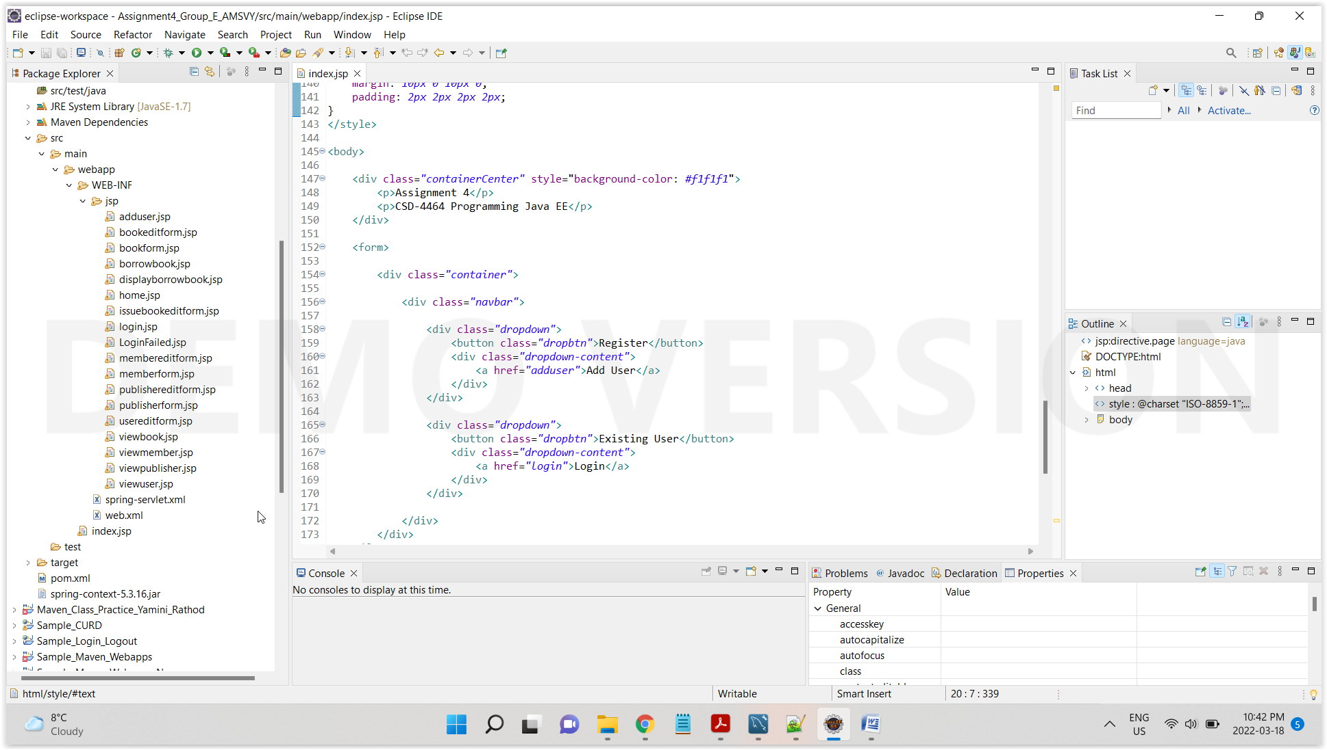

Edited Borrowed Book

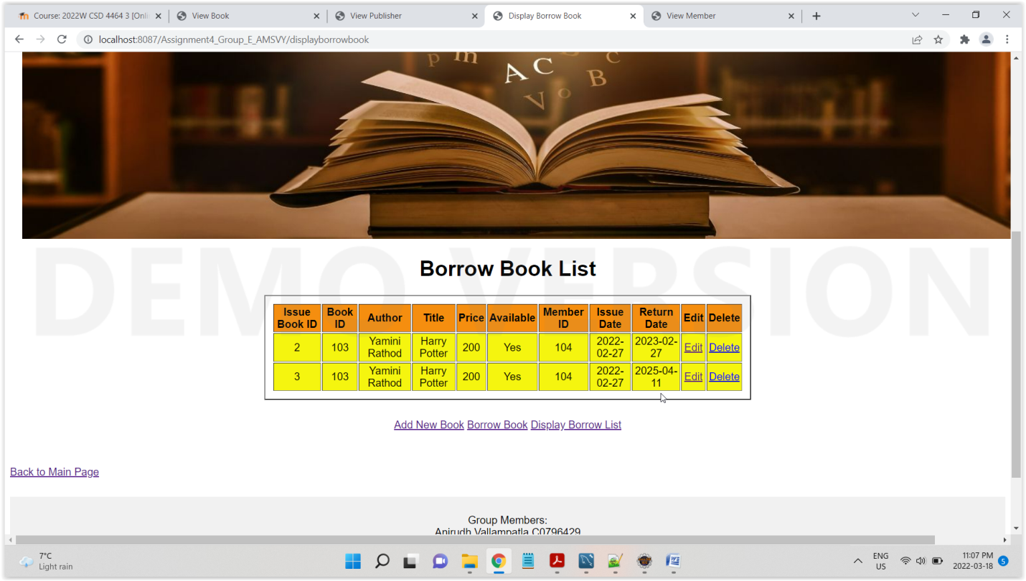

Delete Borrowed Book

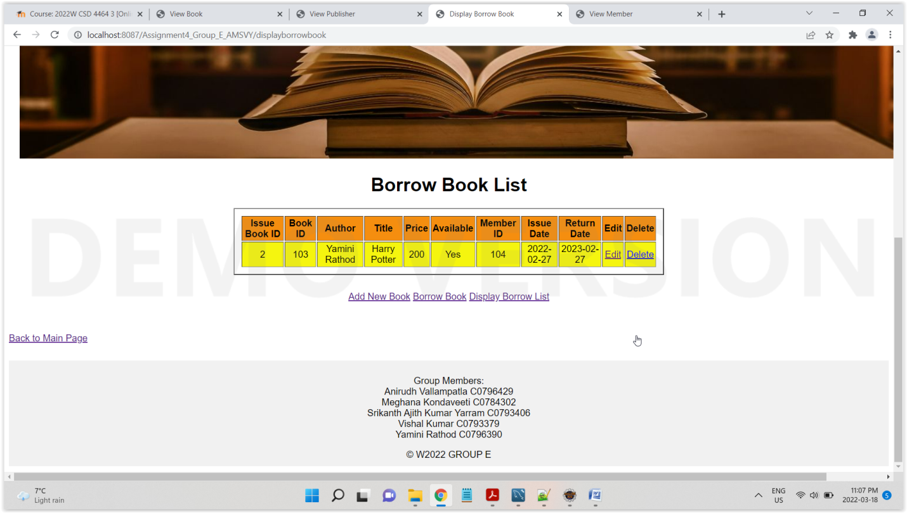

Logout from Application, it would redirect to main Index Page

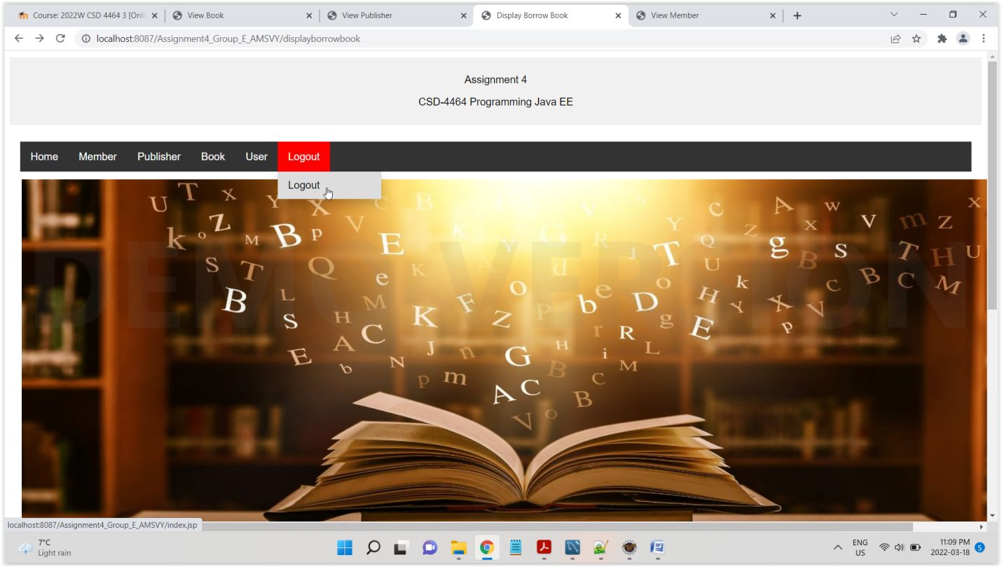

Main Index Page

